**Exercise: Web API**

## Messages

Let's create a **Messages** **Web API** in which Users can choose a username and chat with each other.

## Database

The **Database** of the **Messages** application needs to support only **1 entities**:

### Message

* Id - a GUID String, Primary Key
* Content - a **string**
* User - a **string**
* CreatedOn - a DateTime object.

Implement the entities with the **correct datatypes**.

## Functionality

Users should be able to create messages and list all messages, ordered by createdOn.

There are 2 endpoints you must implement:

* /api/messages/all – **Returns** all **Messages**, ordered by CreatedOn
* /api/messages/create – **Creates** a **Message**, by a given **content** and **user**

## Front-End

You will be given a simple HTML page, styled with Bootstrap. The page is constructed to be the Front-End of the Messages application. It has a simple form for choosing your current Username and a simple form for sending messages. It also has a list of messages sent, which is all the messages that are currently in the database of the application.

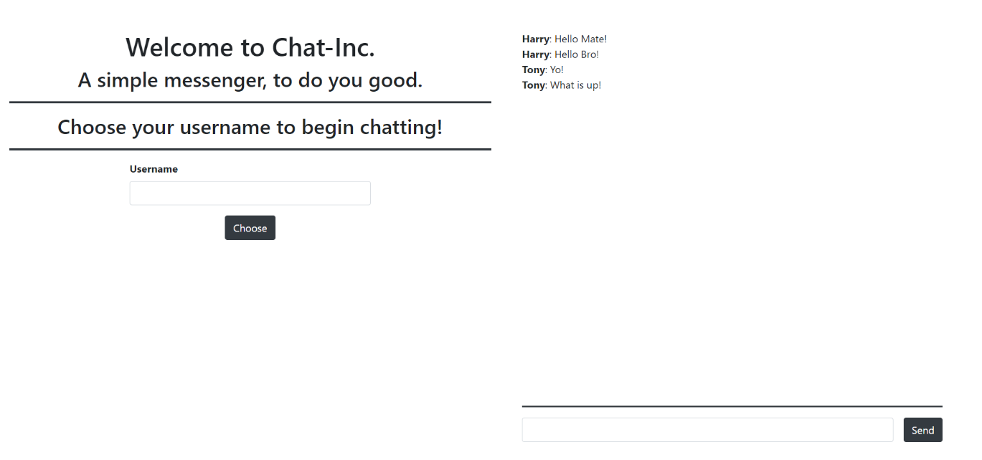

You do not need to touch any of the CSS. You will however be given a app.js file which you must implement. The Web API must be consumed, and you must do that with JavaScript.

### Username Functionality

Upon Choosing a Username (clicking on the [Choose] button) the following view should appear:

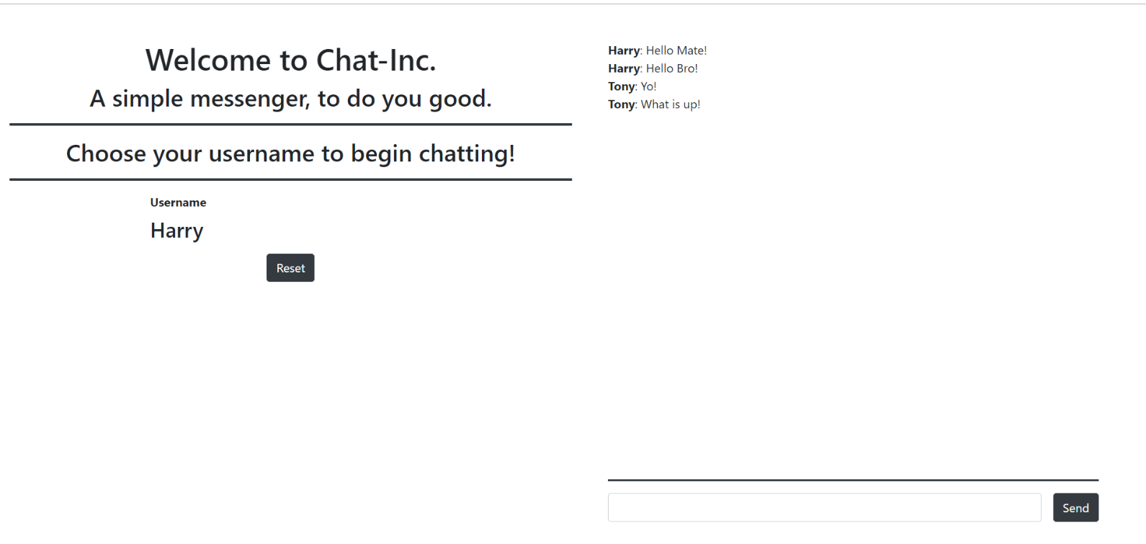

Upon clicking [Reset], the **Username** should be reset, and you should be able to choose another **Username**.

### Messaging Functionality

Upon clicking on the [Send] button a message should be sent to the **Web** **API** and it should be **created** in the database. All of the **messages** should be **refreshed** (**listed again**) so that the new message can be attached.

### Micro-Validations

Introduce micro-validations such as:

* You should not be able to send a **message** **without having** chosen a **Username** first.
* You should not be able to choose an **empty Username**.
* You should not be able to send an **empty Message**.